

**iVOTE**

**Faculty User Guide**

Version 1.0

12/04/2011

Jeremy Nagy

Presented by:

TEAM A

Table of Contents

Introduction 1

Logging in For the First Time 1

Logging in 3

Password Recovery 5

Changing Password 7

Voting Process 8

# Introduction

The iVote system is a website to provide the faculty members voting functionality. The website will serve as the medium through which willingness-to-serve forms, nomination forms, nomination and election procedures, duties of the offices up for election and any other related forms, are delivered via email to eligible voters and eligible candidates. All functions of the website are fully automated allowing faculty to perform all necessary voting steps easily and without interrupting their daily routine. As each phase of the election gets under way each faculty member will be sent an email letting them know that there is something new that might require their attention.

# Logging in For the First Time

For your first time logging in you will receive an email to your Kutztown email account providing you with a link to set your password.

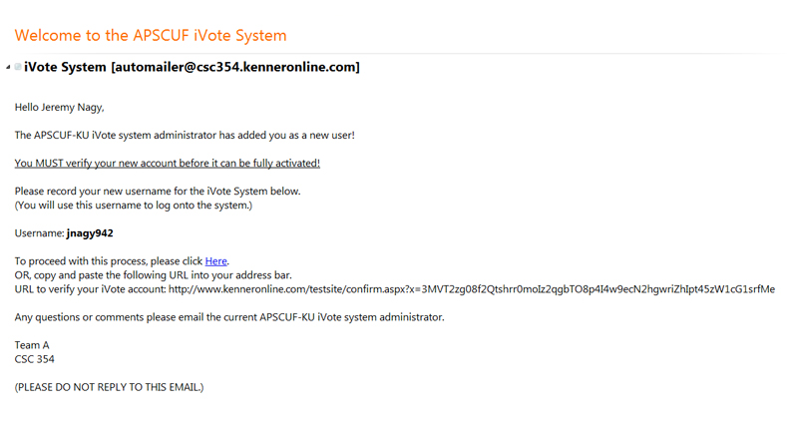

*Figure 1: Example of email sent to faculty in order create account*

Follow link OR copy and paste URL in Internet Explorer address bar.

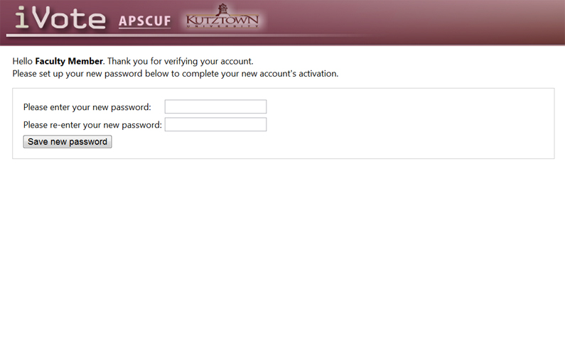

*Figure 2: Create password screen*

Enter a password in twice and then press “Save new Password” to proceed forward.

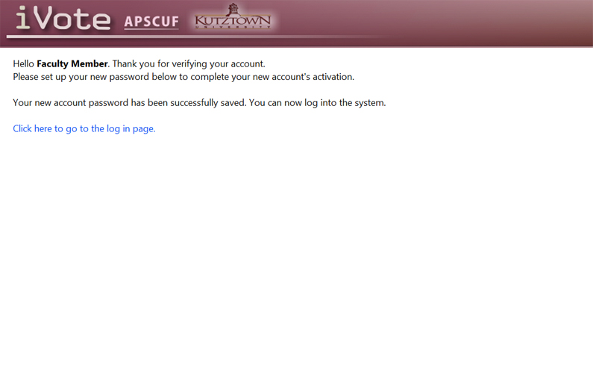

*Figure 3: Confirmation of your account's activation*

From here you can proceed to the log in page.

# Logging in

In order to take part in the voting procedures this first step is to log in. Please open your web browser Internet Explorer or other preferred browser. Now click on the address bar and enter [www.kutztown.edu/iVote](http://www.kutztown.edu/iVote)

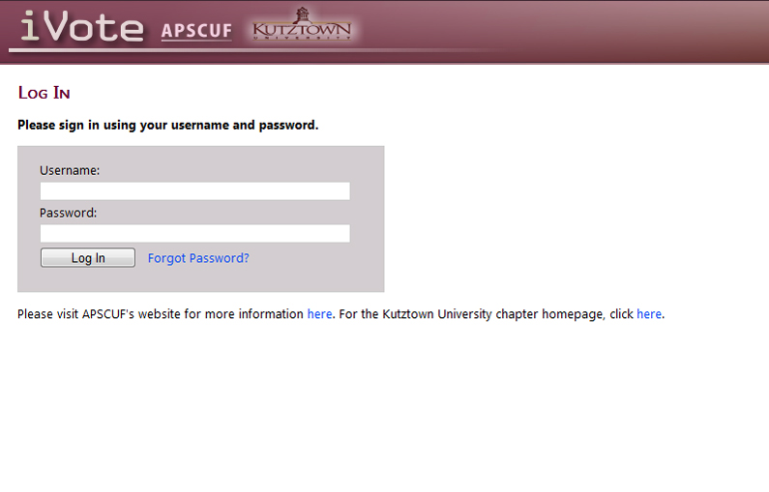

*Figure 4:Figure 4: Log in screen*

Here you enter your password that you created when you activated your account. If you have forgotten your password you can click on the “Forgot

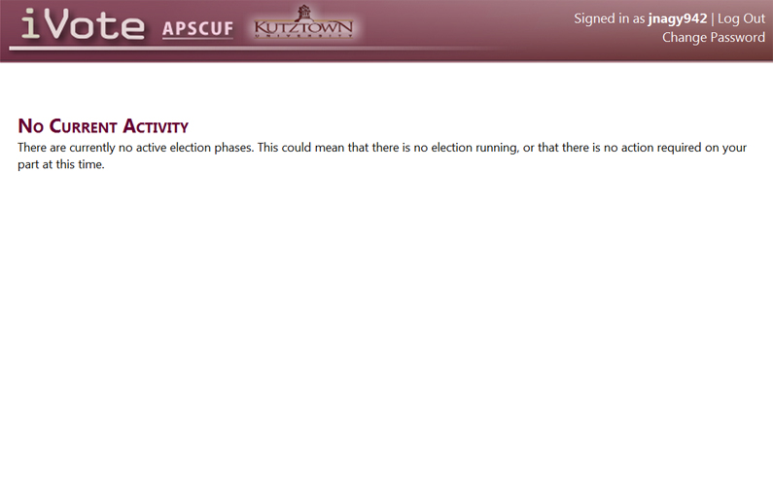

*Figure 5: Homepage of iVote*

The homepage will **ALWAYS** look like this unless there is voting step, which you need to take care of. The website is fully automated you will never have to search in order to find out what you need to do next. The site’s homepage will always advance to appropriate step for you to do according on the timeline of the voting process.

# Password Recovery

# C:\Users\Jeremy\Pictures\website user manual\forgot pass.jpg

*Figure 6: Forgot Password*

If you selected “Forgot Password?” you will be brought to this screen where you can enter your Kutztown email address and you will be sent an email to recover your password.

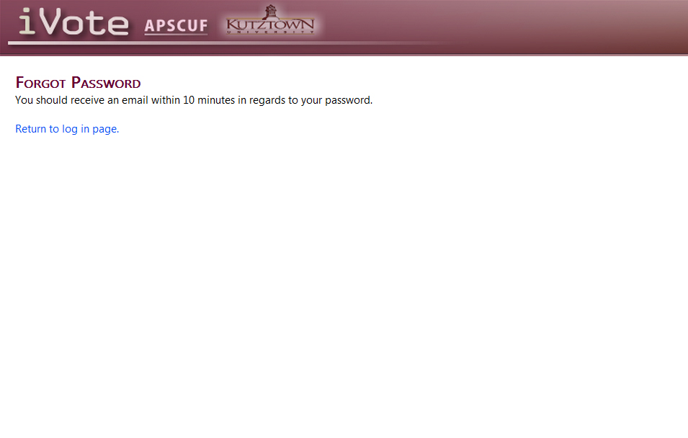

*Figure 7: Forgot password confirmation screen*

Once your email has been accepted you will receive an email to enter your new password.

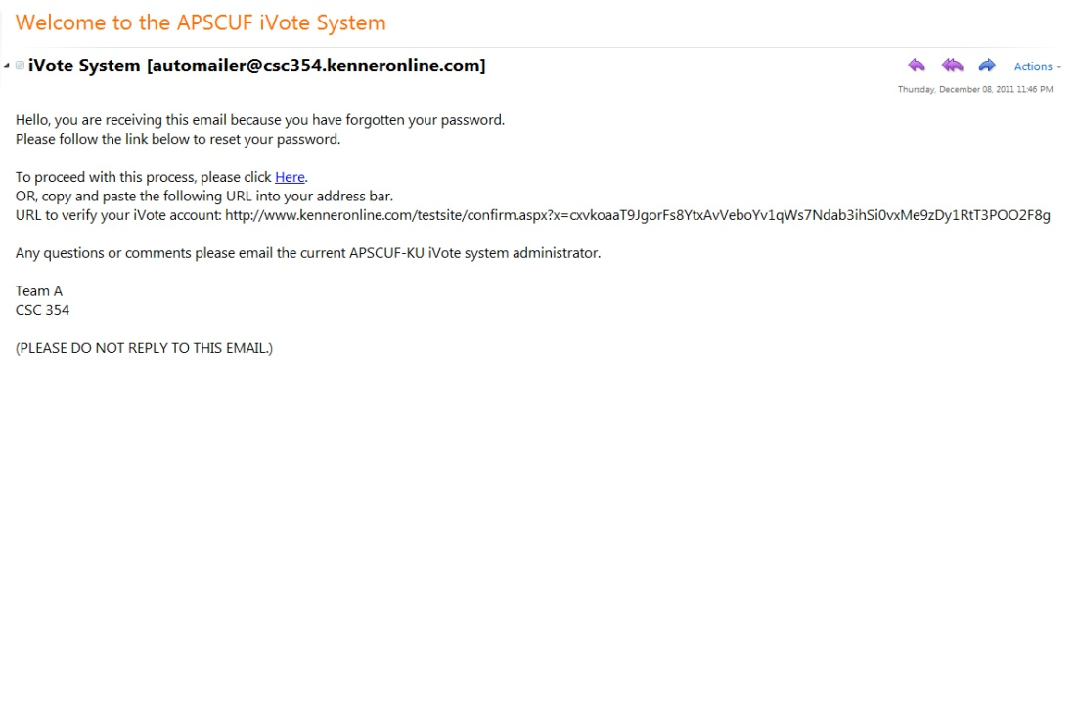

*Figure 8: Email for password recovery*

Follow link in email to enter your new password. This link brings you back to *Figure 2* where the process continues.

# Changing Password

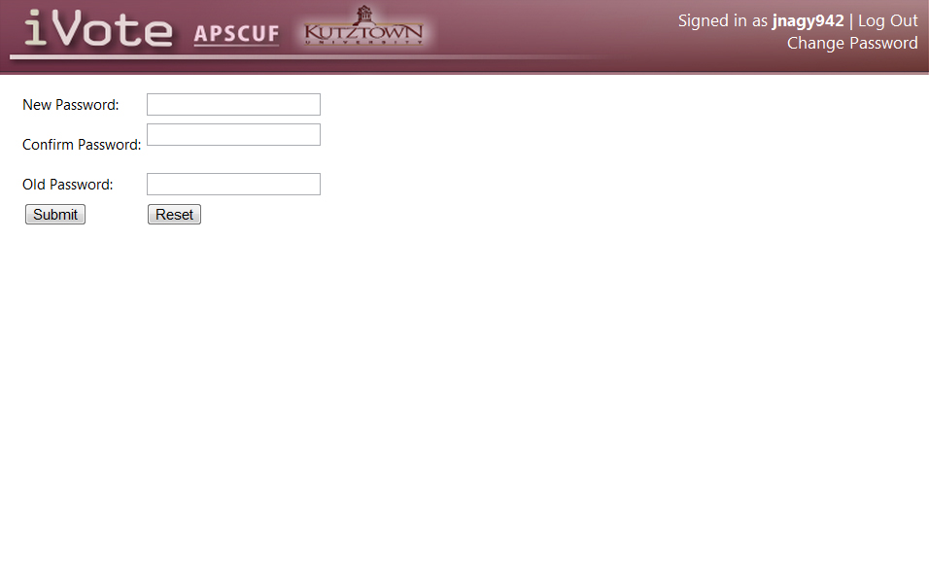

*Figure 9: Change password*

If you desire to change your password you only have to select the text under your login name. Once selected you will be brought to this page where you enter your new password twice and your old password. After selecting submit you will be greeted by a confirmation page.

# Voting Process

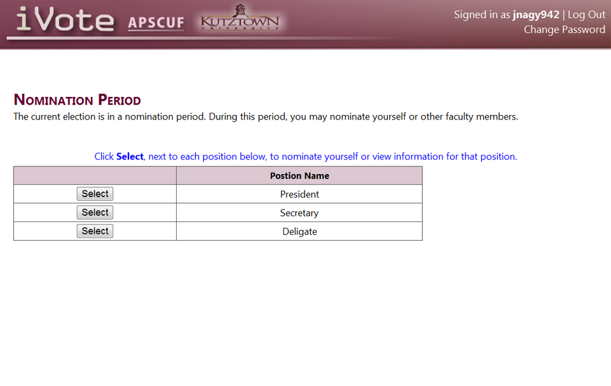

*Figure 10: Nomination screen*

During an election period the homepage will change automatically displaying your new options. In This period you have the option to nominate a faculty member for any current positions being offered. After you have selected a position to nominate for you will be given the option to nominate yourself or another faculty member.

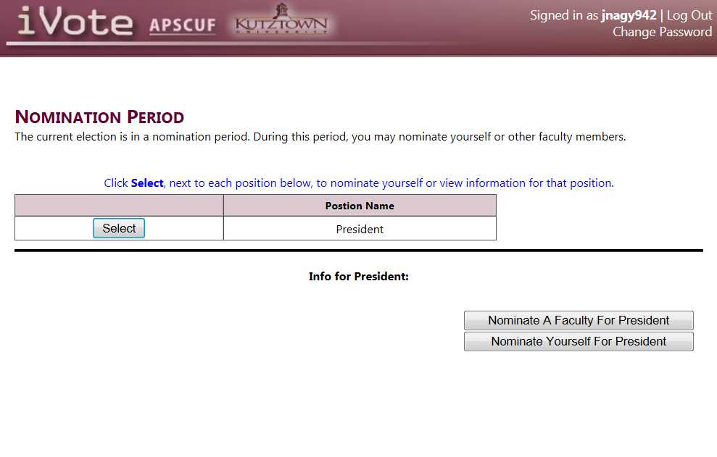

*Figure 11: Nominate for specific position*

Once you have chosen a position to nominate someone for you are given the option of nominating another faculty member or yourself.

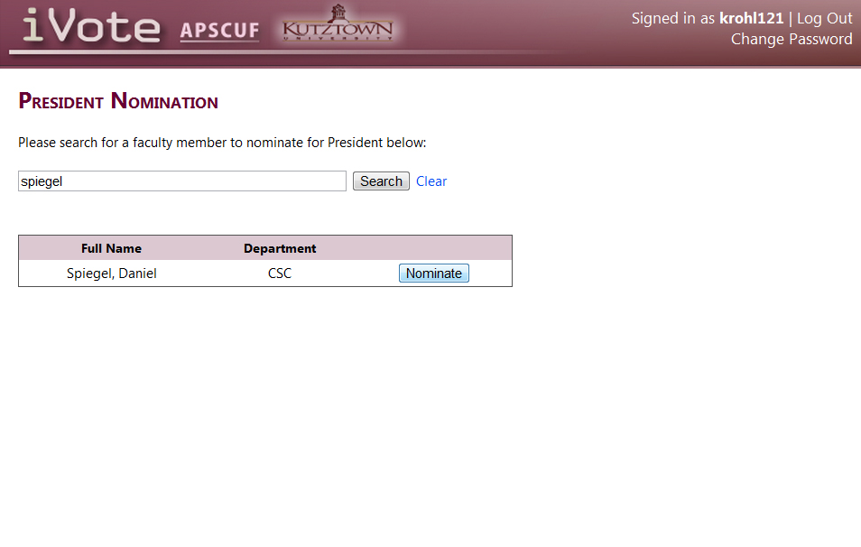

*Figure 12: Nominate a faculty member*

If you choose to nominate a faculty member, you will be brought to a search page where you can search by name and then choose that individual.

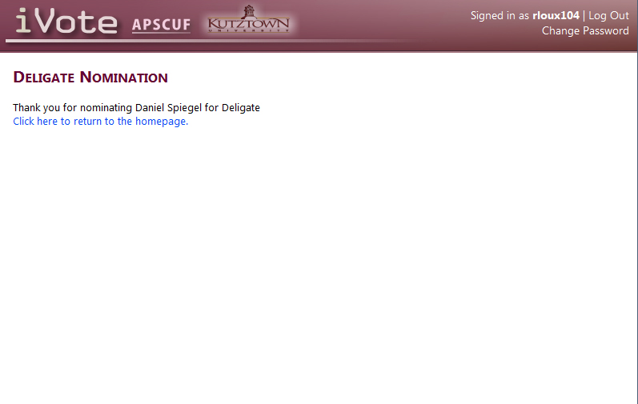

*Figure 13: Confirmation of nomination*

Once you have submitted your nomination you will receive confirmation and then you may return to the home screen to nominate other.

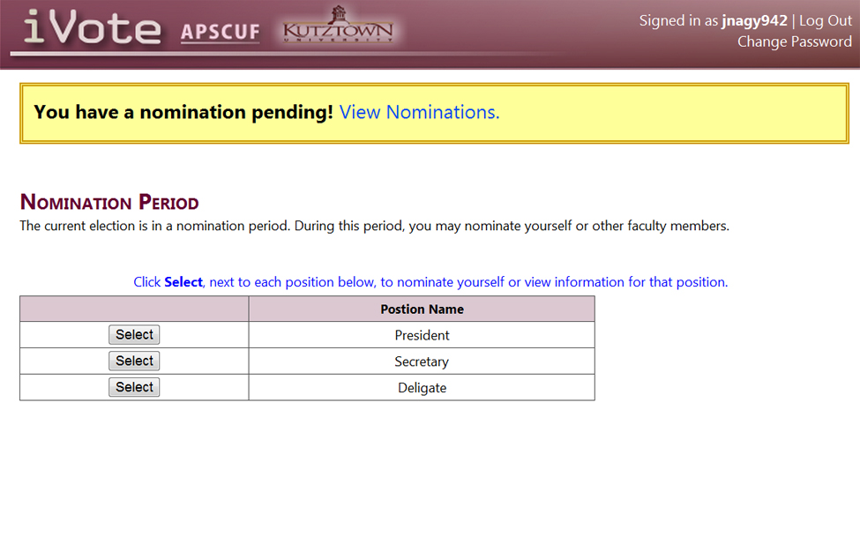

*Figure 14: Alert message*

If at any time during the nomination period, you are nominated by someone else you will receive an email to your Kutztown account as well as see a visible alert upon logon.

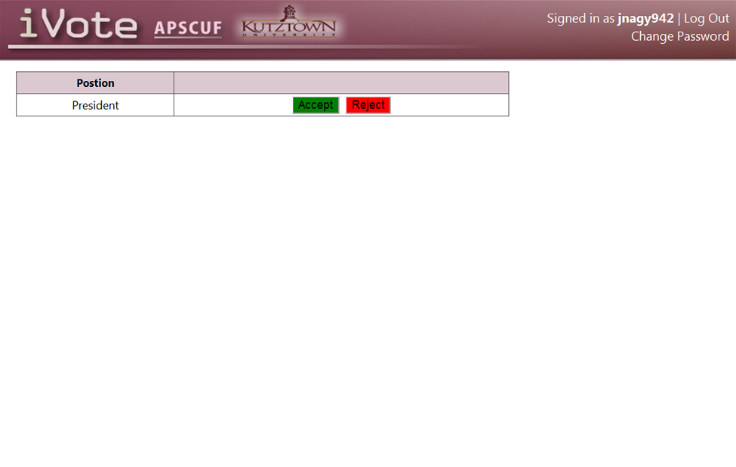

*Figure 15: Nomination acceptance*

After you have selected to view your nominations this is the screen where you can accept of reject any positions that you have received nominations.

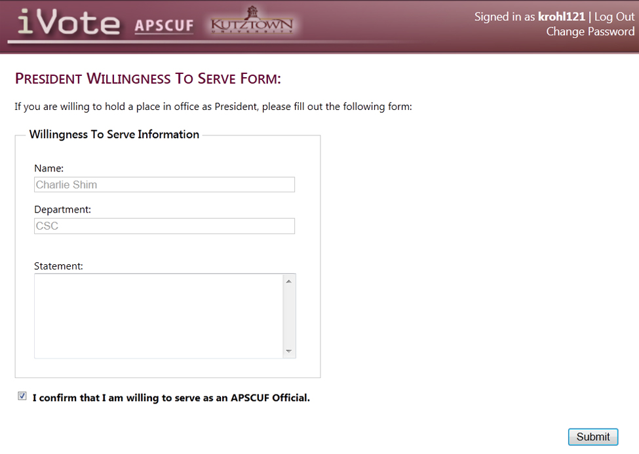

*Figure 16: Willingness to serve form*

After you nominate yourself or accept a nomination, you will need to fill out a willingness to serve form. This form is also required during the petition phase should you get enough petitions to be added to the ballot.

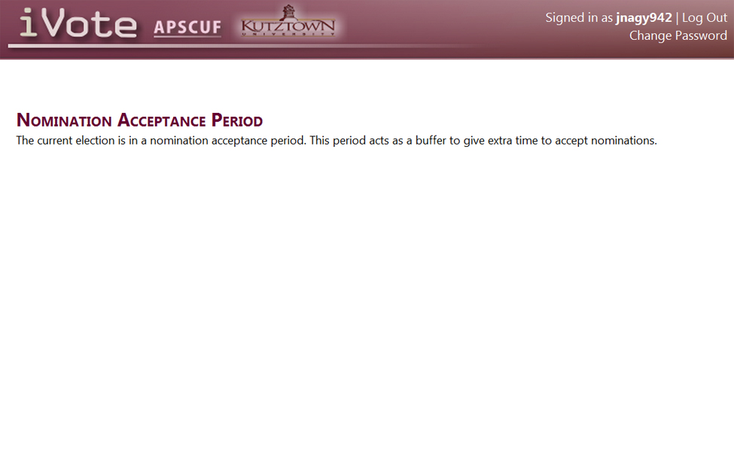

*Figure 17: Nomination acceptance period*

After the nomination period there is a two-week window where faculty have the opportunity to accept or reject any nominations that they may have received.

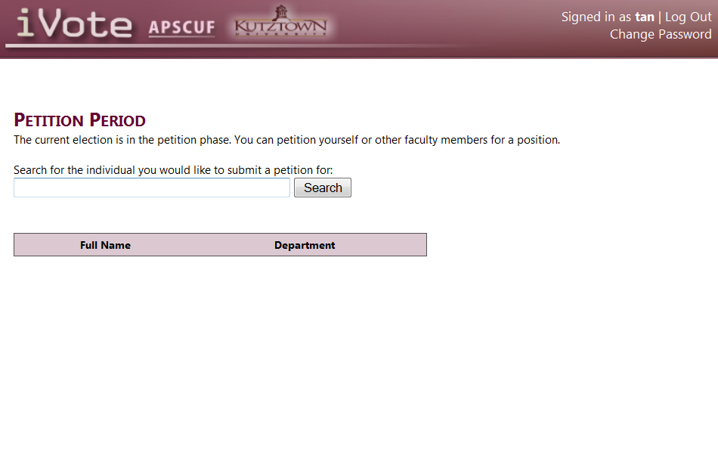

*Figure 18: Petition period*

In this, phase you able to start a petition for yourself or another faculty member. With 10 signatures, you are able to get a faculty member on the ballot. You start entering a part of the name of the faculty member you wish to petition and click search.

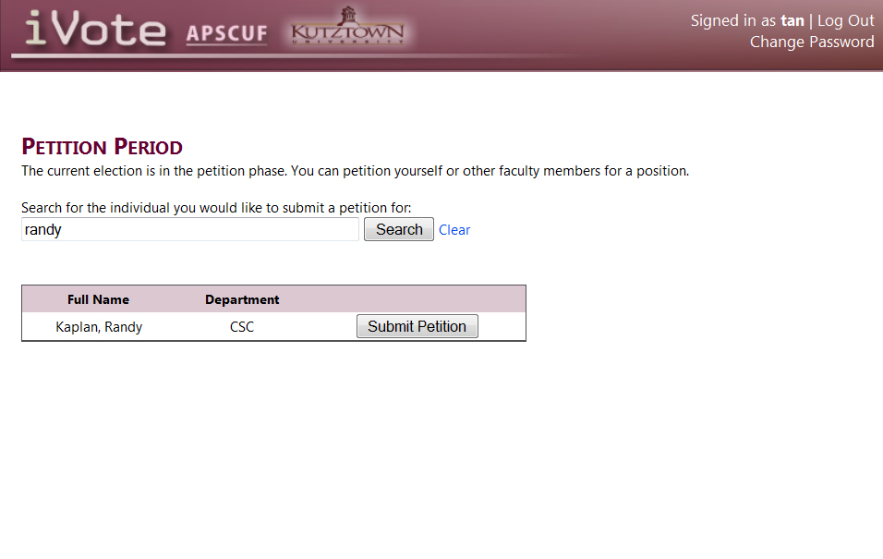

*Figure 19: Search results*

After you have performed a search you can select the name of the faculty you wish to submit a petition for.

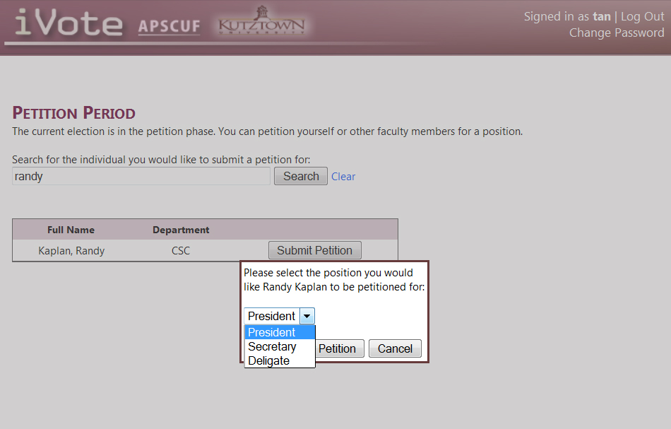

*Figure 20: Selecting position to nominate for*

Here you given a choice of the positions to select from.

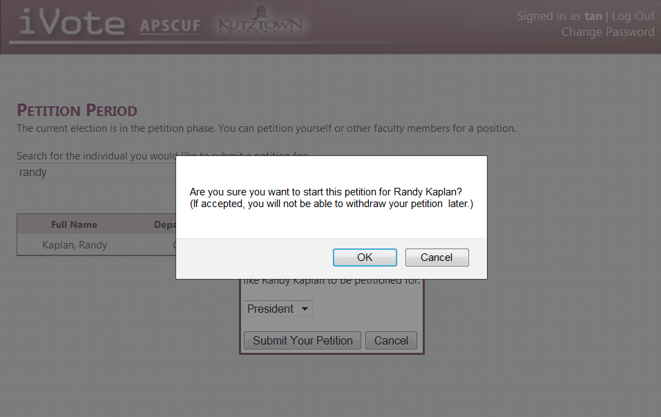

*Figure 21: Confirmation box*

As added security, you are asked to confirm your selection.

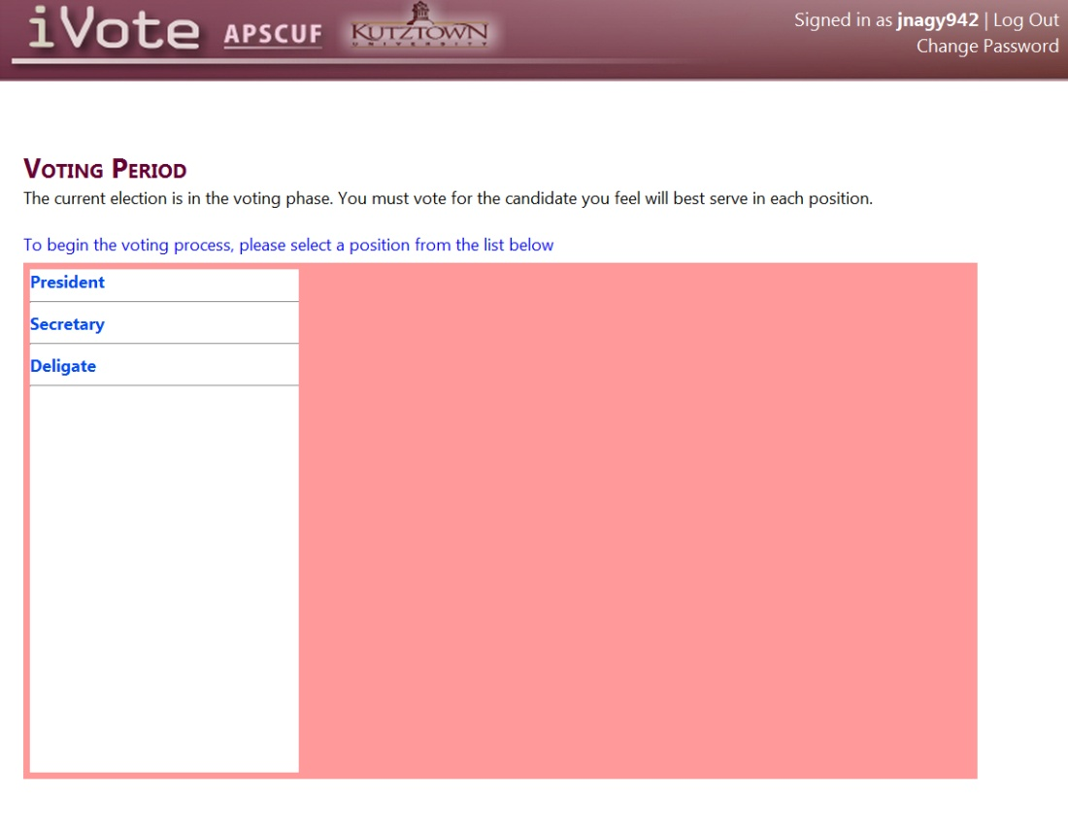

*Figure 22: Voting period*

At the start of the voting period you will receive an email letting you know that it is time to vote. When you log in you will be shown the ballot right away and can start the voting process. You start by selecting the position you wish to vote for.

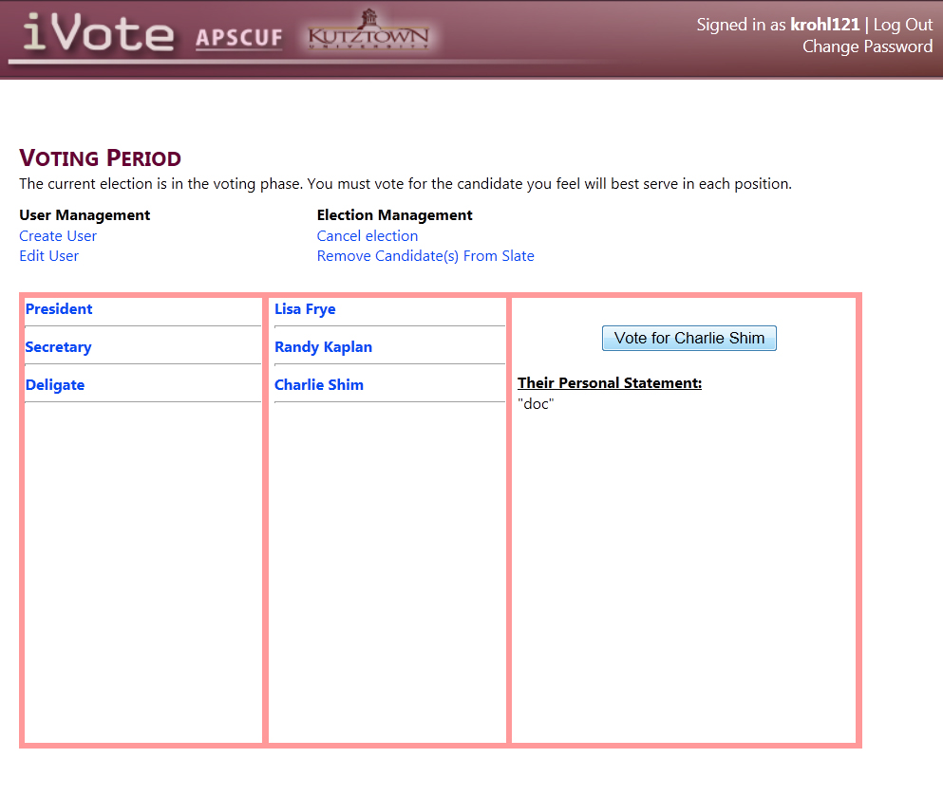

*Figure 23: Vote for candidate*

For each position you can select a candidate to vote for. Press the vote after each position you wish to vote on.

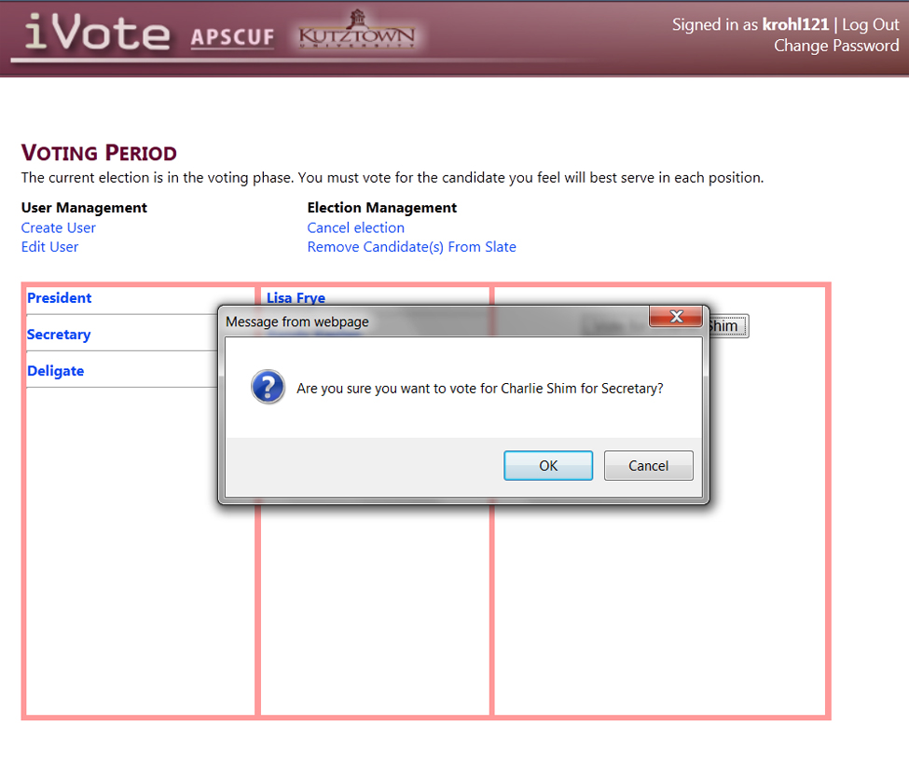

*Figure 24: Confirmation box*

As before you will be presented with confirmation box to give final approval for your selection.

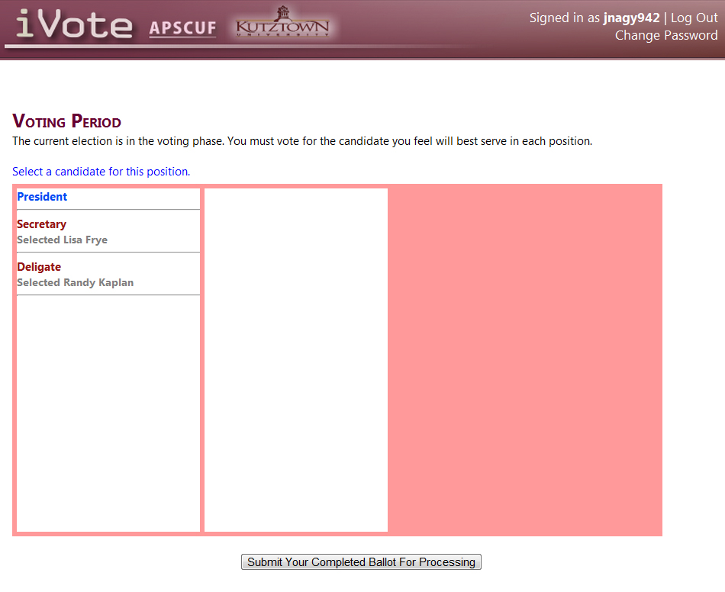

*Figure 25: Submit ballot*

After you have made your selection for each position you just need to submit your ballot for processing.

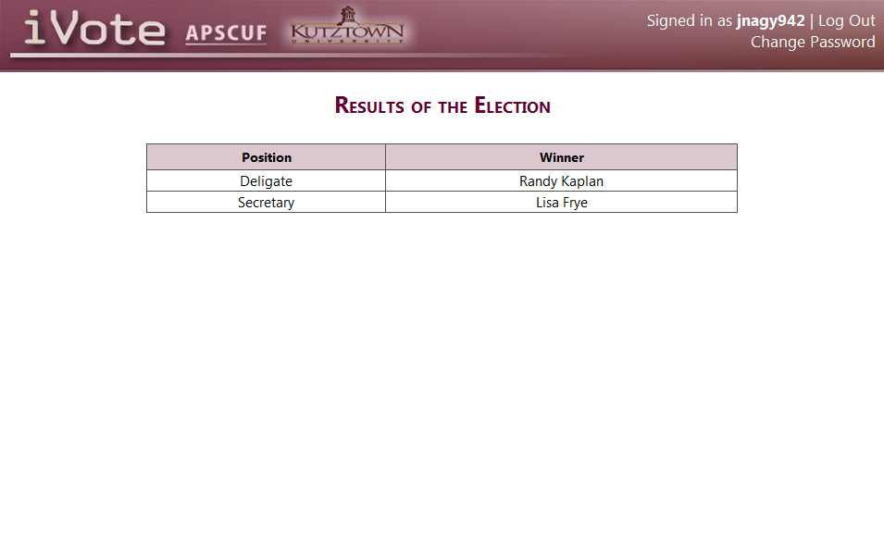

*Figure 26: Results*

After the election the results are posted on the homepage.